Kyle Remillard

Alexander Cromer

Mingyuan Yan

CSCI 3410

30 November 2017

LAB4: Company Database JDBC and DBMS Report

Our program uses a combination of SQL and JavaFX to create a GUI for our company database. The database uses the DbConnector class to connect to a GoDaddy SQL server and displays any errors if the connection fails. The GUI consists of 5 views, each representing the different tables within the database. Each view has a table that displays all the table’s data, an area that allows for the insertion of a tuple, and a button that displays the table’s metadata which includes the creation of the table inside a text area box. You can navigate to the other views by clicking on their respective names at the bottom.

To run the program, simply create a project in eclipse, import the archive file into the project, and move the folders (application, controller, and model) into the src. Move the lab4.iml file into the root of the created project. The project needs to have the latest JDBC drivers as well as JavaFX runtime 9.0.1 or else the user runs the risk of an error.” You might have to rebuild the library.

“C:\Users\Alec\AppData\Local\Microsoft\Windows\INetCache\Content.Word\error.png”

The next pages show:

* 2/3 - Each table with their respective data
* 4 - Insertion/deletion/errors
* 5 – Custom entries/ output for errors
* 6 – Metadata / table creation

This is the employee table

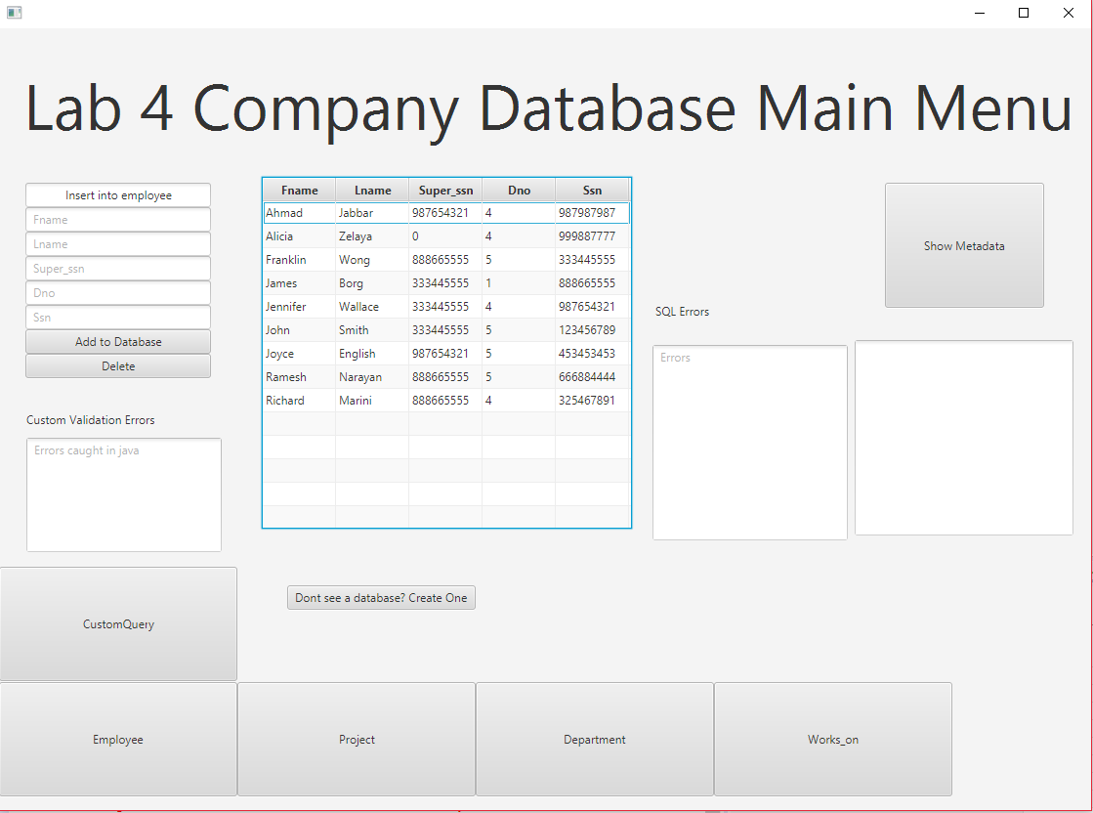

This is the department table

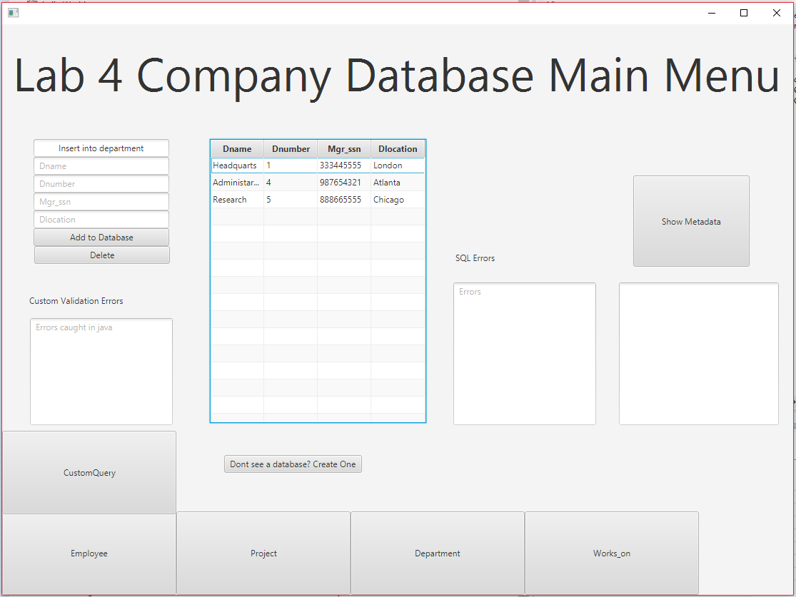

This is the works_on table

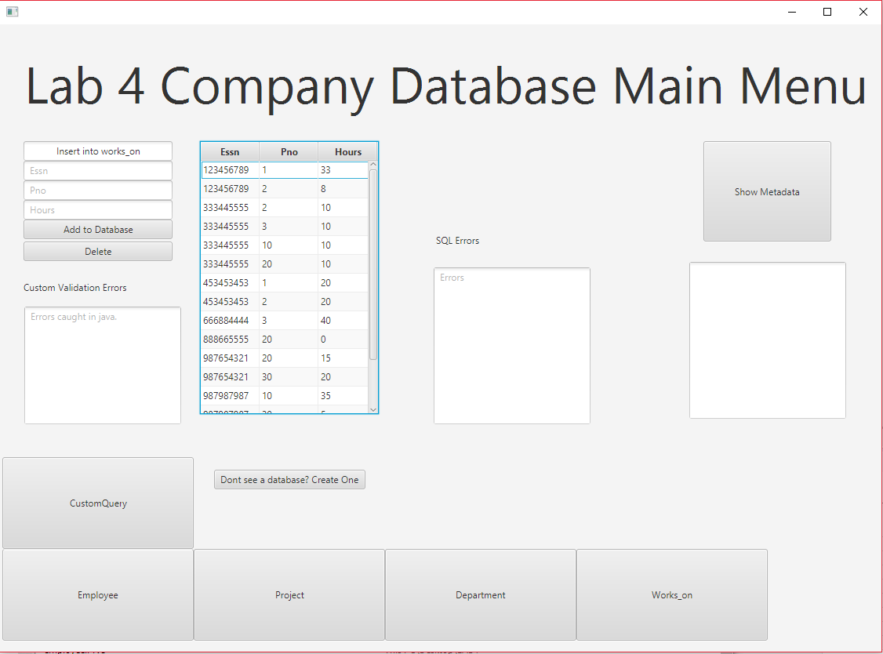

This is the project table

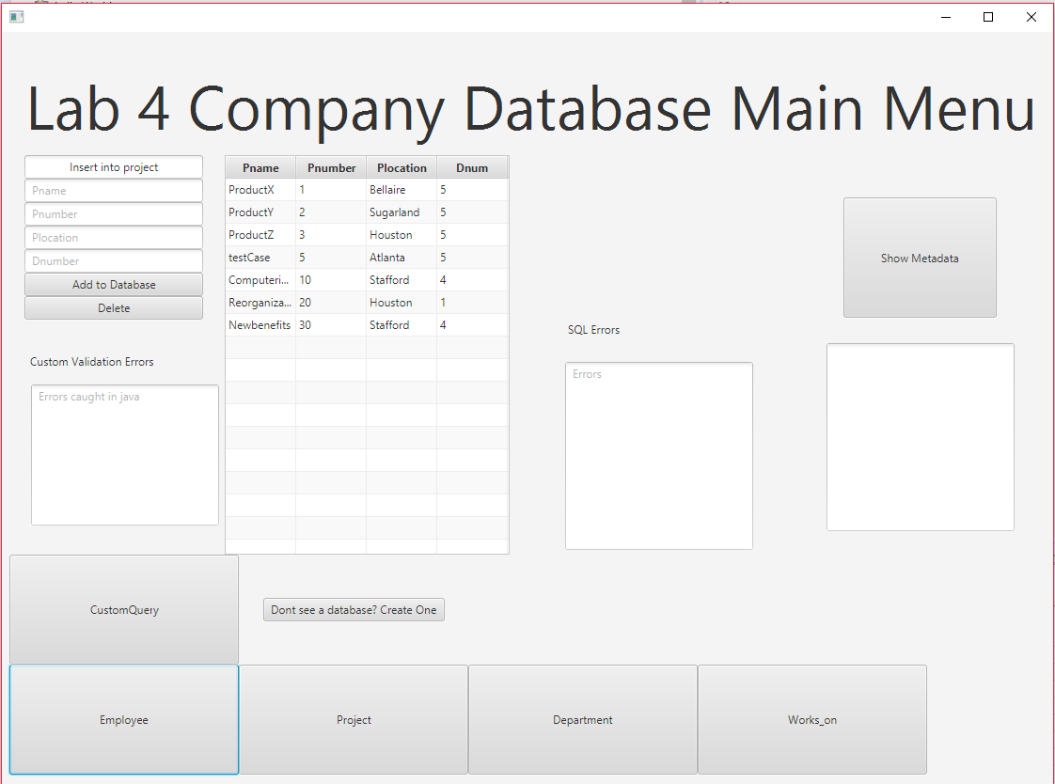

Insertion into a table works

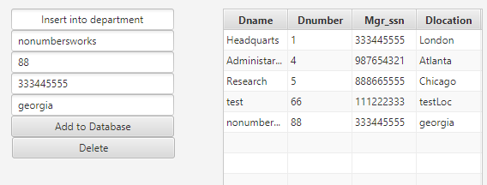

Deletion functionality works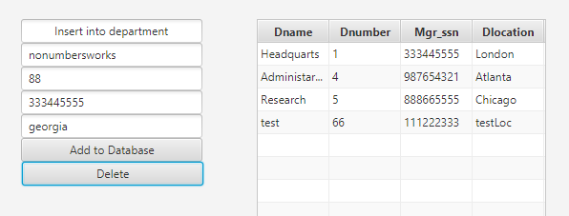

Displays errors for invalid entries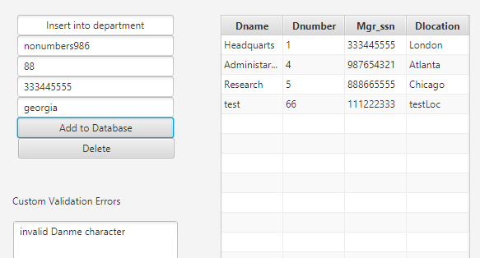

Custom SQL entries can be entered into the “Enter SQL Queries…” box, and the outputs will display in the “Output for Queries” box.

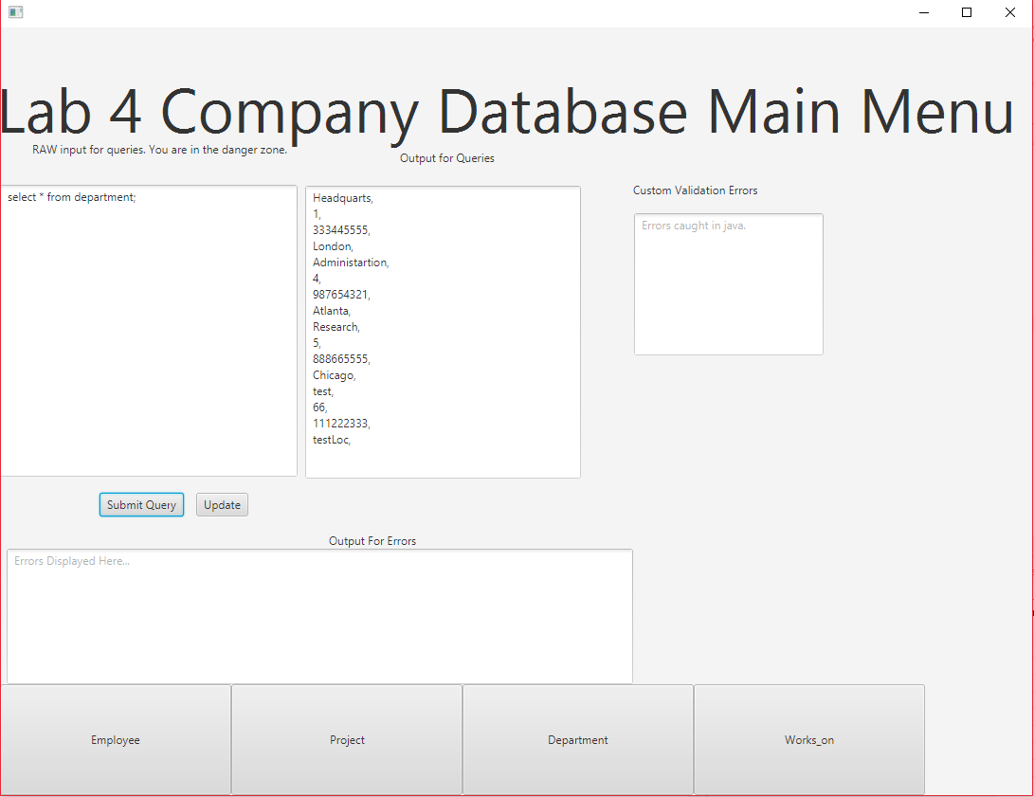Any SQL errors will appear at the bottom, and validation errors on the right

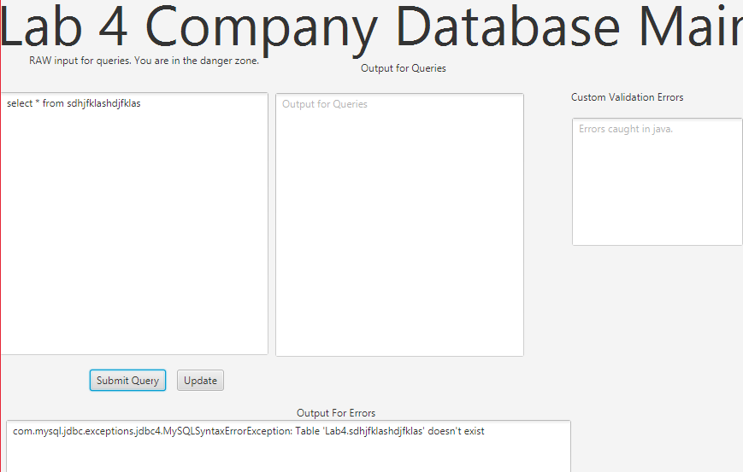

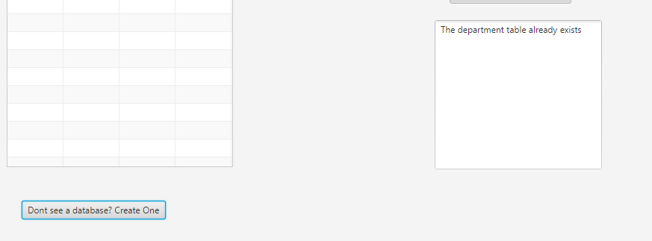The “Don’t see a database? Create one” button creates the table if it doesn’t exist, else it displays a message saying “The _____ table already exists”

The Show Metadata button displays all of the components in a respective table, such as primary keys, restraints, and tuple information.

